BU Memo Senior Design ENG EC 463

To: Professor Pisano, Professor Alshaykh, Professor Kia

From: John McCullough, Shantanu Bobhate, Brian Tan, Bandhan Zishanuzzaman, Teng Zhang

Team: 2

Date: 11/20/2015

  Subject:    RightAlert First Deliverable Report

**1.0 Recorded Video Object Detection**

**1.1 Description and Goal**

In order to implement the first version of our detection algorithm, we required footage that would attempt to simulate the actual conditions for our project. We used a stationary laptop web camera to film a person walking alone, two people walking side by side, and a biker. Our objective was to use this video data and be able to differentiate between a person/biker and a car represented by two people walking side by side.. We used the Photo Booth software on a Macbook Pro to record the videos and convert them to a 480p format. One requirement for the current algorithm was that we needed a base image with no moving objects. We stored these video files to a folder in the XCode project. We then used our detection algorithm to classify objects as Class A (Objects wider than a certain threshold width) and Class B (Objects narrower than a certain threshold width) objects. We used these initial tests to come up with the parameters required to make this distinction, namely a detection line and the threshold width.

This test demonstrates our ability to both detect and classify objects through the use of image processing. This is directly relevant to our final design. since we will have to detect moving objects on the road and be able to classify such objects as cars, bicycles, pedestrians, etc. Being able to identify objects properly will allow us to give more accurate results.

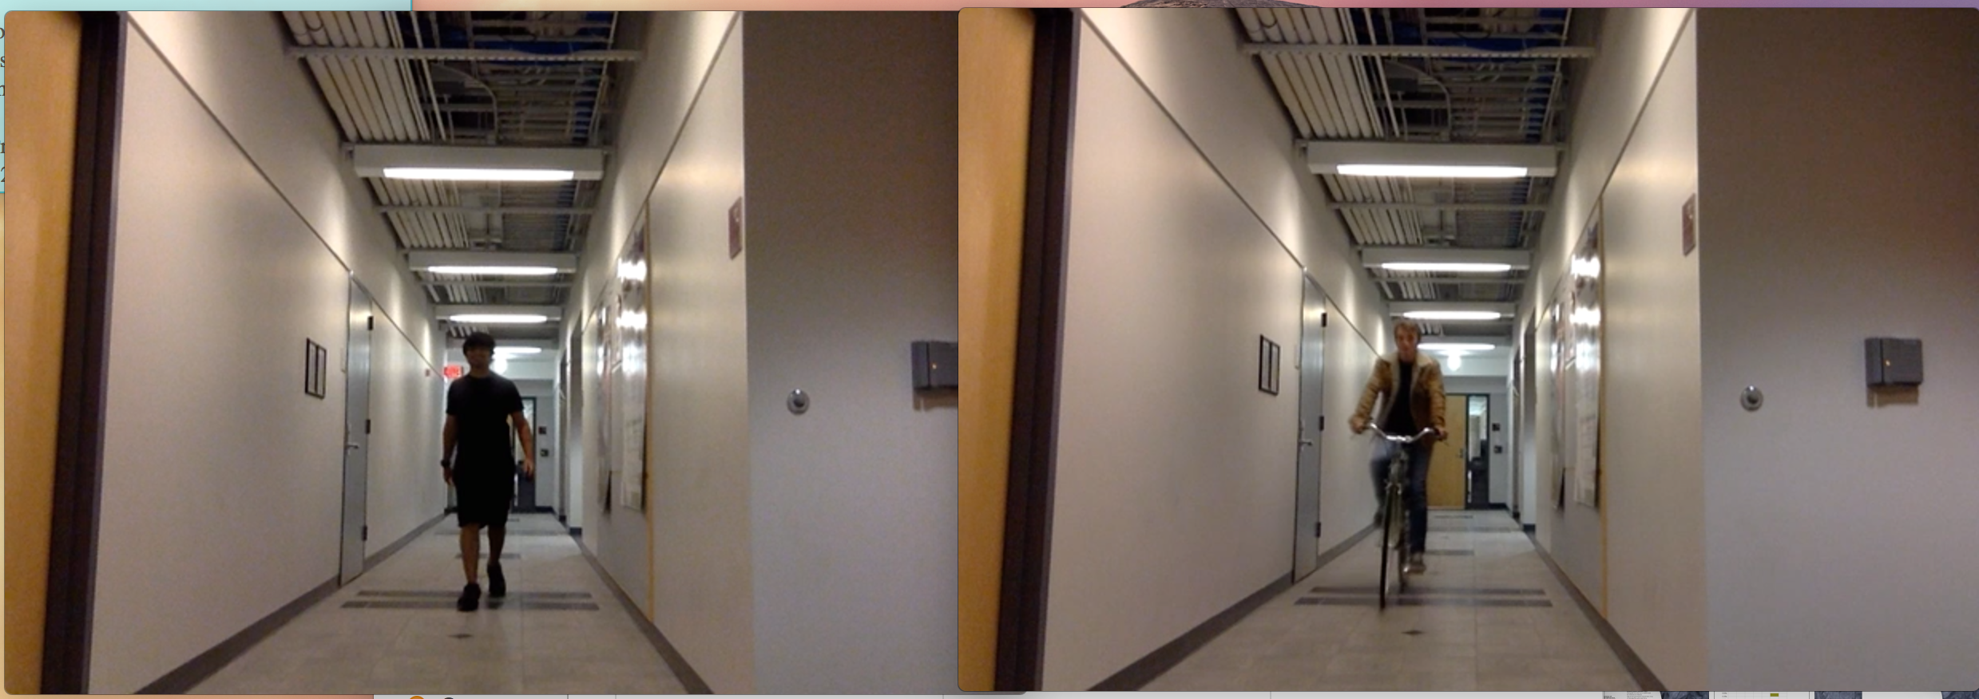

**Fig 1:** A person versus a biker

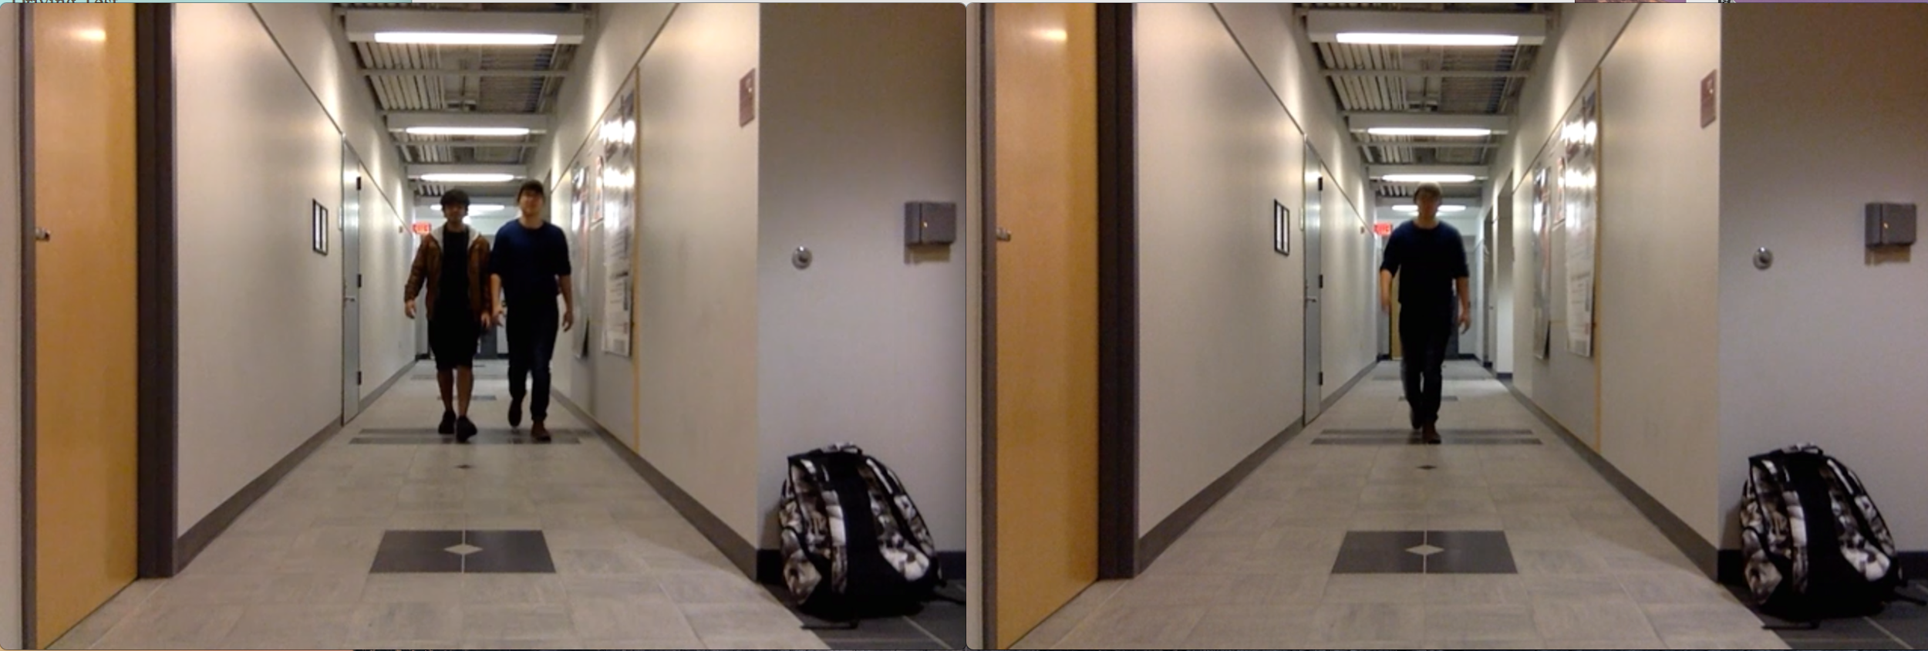

**Fig 2:** 2 people versus 1 person

**1.2   Procedure**

        In order to create the parameters to determine whether an object is classified as class A or class B, test footage of objects of both types should be recorded prior to the test day. For type A, the larger objects such as cars and trucks, record two people walking side by side down the hallway. This would represent an object with a width that is much greater than a pedestrian or a biker. For type B objects, we need to have two sets of videos, the first containing one person walking down the hallway and the second containing a biker riding down the hallway.

Check the names of the videos to be demonstrated. Open the test detection algorithm file in XCode. Run the program and enter the complete filename when prompted to do so. Set the detection line at the desired position by right clicking in the window at the desired position. Wait for the program to end or exit the program by pressing the ‘esc’ key once the detection has been completed. Re-run the program with the same file and activate the debugging mode this time. Re-do the steps for all the different test files (debugging mode not necessary). Check the output log and images for the test runs.

**1.3   Verifiable Result**

The algorithm detects a moving object (larger than a certain threshold area) in the frame and draws a green bounding rectangle around it. It records the width of this object at a certain detection line and determines whether it is a Class A or a Class B object. It outputs the result to the console as well as a text file. It also captures an image of the frame at this instance and saves it to the ‘output_files’ folder. This image can then be cross-checked with the log to determine whether the detection was correct or not, since we know the expected result for each file. The log file and the images also contain timestamps for verification in the case of confusion.

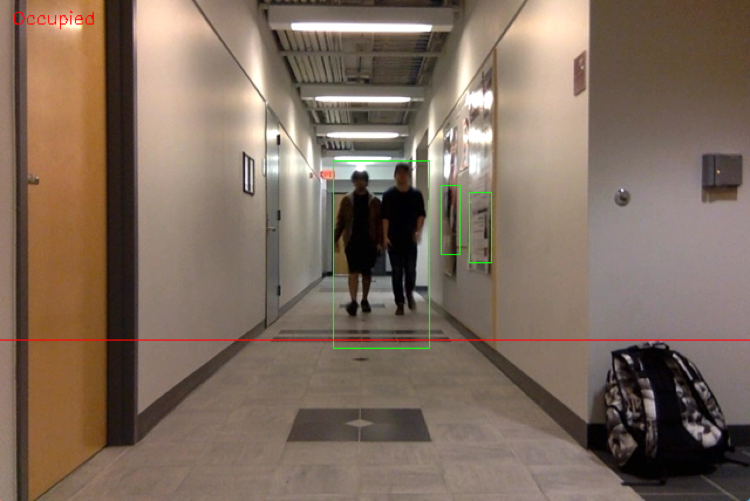

**Fig 3:**  2 Person detection

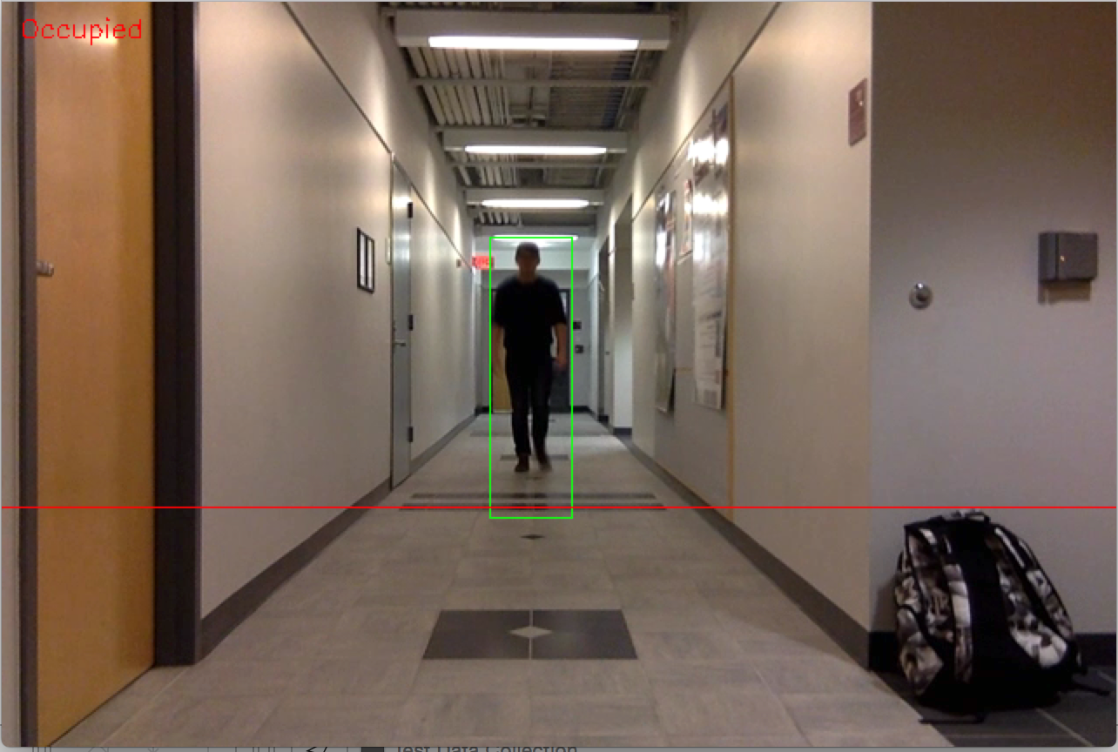

**Fig 4:** One person detection

**2.0 Live Video Object Detection**

**2.1 Description and Goal**

The live video demonstration will serve as a means to test the parameters that determine object detection. These parameters were determined based on previously recorded video. Based on the success or inaccuracy of the algorithm, the parameters will be altered to decrease the probability of a false detection.

**2.2  Procedure**

In order to display the algorithm’s capabilities, it will have to be tested on a number of different cases. The algorithm will be run on a live video feed from a laptop web camera, again using the Photo Booth app on the Macbook Pro. The camera will be set up on a chair outside PHO 111 in the middle of the hall and pointed down the hallway. For the first test, there will be one person walking from down the hall towards the camera. For the second test, two people will come down the hall. Finally, the third test will have a biker ride down the hallway.

Open the test detection algorithm file in XCode. Run the program and enter ‘c’ when prompted for the file name. This will target the webcam as input. A window will pop up showing the camera feed. Set the detection line at the desired position by right clicking in the window at the desired position. Wait for the program to end or exit the program by pressing the ‘esc’ key once the detection has been completed. Re-run the program for the other test cases.

**2.3  Verifiable Result**

After running the algorithm on a number of different scenarios write specific data in “output.txt” unique to each test case. Each test will yield its:

* Timestamp
* Class of object detected (Class A or B)
* Width of bounding rectangle
* Area of bounding rectangle
* Image at detection

The timestamp will help us to differentiate the new tests with older data previously recorded. To determine if the algorithm correctly categorized the live test subjects, we cross reference the recorded class of object with those from the recorded video detection. If our algorithm incorrectly identifies an object, we look to its outputted width of its bounding rectangle. Since the algorithm categorizes objects based on this width, we will know to modify this threshold for more accurate results in the future. In addition, the algorithm uses a ‘minArea’ variable to filter out reflections and shadows, which would normally show up on the video feed. The outputted area of the bounding rectangle from our tests will provide a better threshold for this filtering. By the end of our test, if we see a large amount of false detections we will be able to use the data collected to improve our algorithm.

**3.0 Data Collection**

**3.1 Output File**

Given below is a screenshot of the console output from the testing which is saved in “output.txt”.

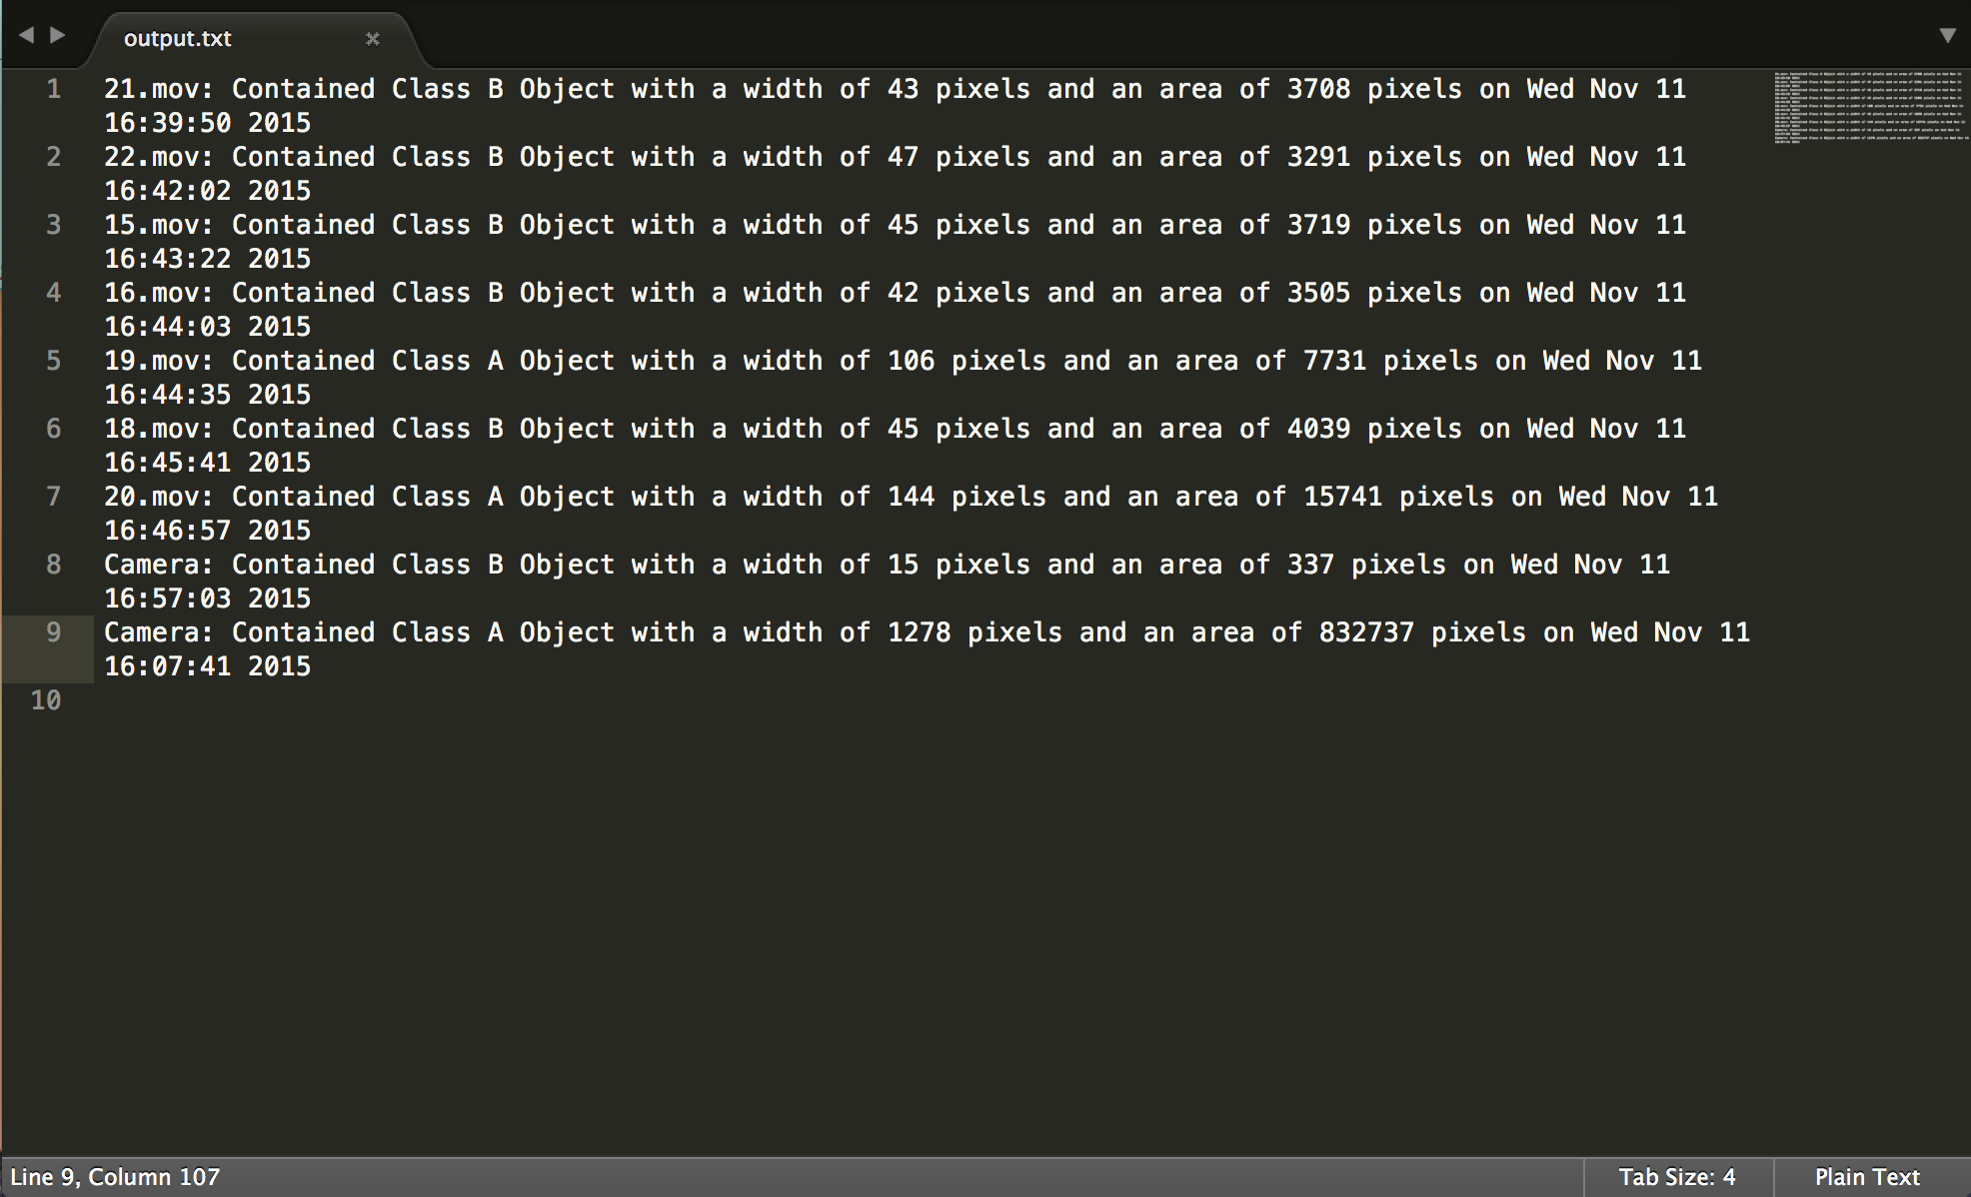

**Fig 5:** Console output provides test data to compare against expected results

The test data for all the videos exactly match the output we had expected**.**

**3.2 Output Images**

The team went through the images captured for every test that was run. The detections were accurate for the videos but not for the real-time capture using the camera. The reason for this was the difference in the pixel ratio of the pre-recorded videos versus the pixel ratio of the live camera video. The background noise in live video added to this inaccuracy.

**4.0 Algorithm Limitations/ Areas to Improve**

After the testing we performed some analysis on the data and came up with following limitations and areas to improve for our algorithm.

**4.1 Base Image**

The detection algorithm requires an initial blank image as its base image for the algorithm to function correctly. This was a problem since we needed an empty hallway when taking a base image. This would be tough to do in the actual area of interest. However, maybe an image could be taken at night when there are no obstacles.

**4.2 Background Noise**

During our testing and data collection phase we noticed that changes in the background like shadows or moving trees were also recorded as movement and so hindered the detection of objects of interest. This could be dealt with by maybe taking into account the direction of the movement or setting a threshold offset for the movement. We could also filter out the background around the area of interest.

**4.3 No Global Storage for Objects**

Contours are calculated for every frame and so there isn’t a global representation for every object. Enabling this would make computation easier since we would have a reference per object and not per frame. We can then track multiple objects in a frame.

**4.4 Similarity between Bikers and Pedestrians**

As seen in Fig 1, there isn’t much difference in the dimensions of a biker and a pedestrian. This poses a challenge to distinguish between a biker and a pedestrian. We could maybe use multiple detection techniques in parallel to accomplish this. Another area to look into is utilizing a custom classifier for subjects like pedestrians, bikers, and cars. With an algorithm searching only for objects that meet the criteria of a specific set of classifiers, moving objects such as trees and shadows will be ignored.